DOSIMETRY TERMINATION REQUEST
Please complete this form to end your occupational radiation monitoring at Florida State University.
Name: |  |  |  |  | FSUID:
Date of Birth: |  |  |  |  | Phone:

I am requesting to end my occupational radiation monitoring at FSU effective:
 | MONTH |  | YEAR

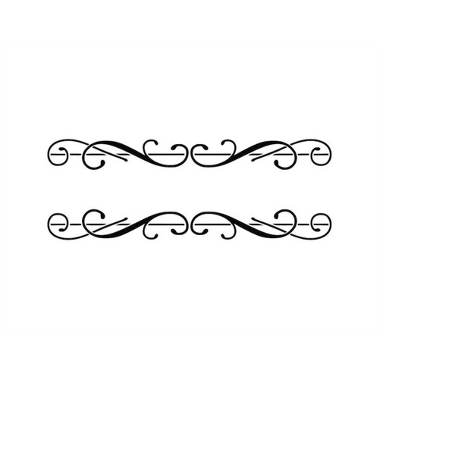
Choose one of the following:
I will no longer be employed by/enrolled at FSU.
I will no longer work with radioactive materials or radiation-producing equipment at FSU.
Send my termination dose report to:
Email:
 | Email Address
Mail
 | Street Address
 | City |  | State |  | ZIP
Signature: |  |  |  |  |  | Date:

FOR RSO USE ONLY
Date Received: |  |  |  |  | FINAL MONITORING PERIOD:
FINAL REPORT Received: |  |  |  |  |  |  | FINAL REPORT SENT:
SENT VIA: | EMAIL |  | MAIL |  |  | SENT BY:

NOTES:

