In accordance with subsection 64E-5.902(1), Florida Administrative Code (FAC),
“Instructions to Workers”, & section 64E-5.1307, FAC, “Training Requirements
for Authorized Users”, and the Florida State University Radiation Safety Program,
the individual named below has been trained in the below subjects and is hereby designated an
 | Authorized User of Radioactive Materials | 
64E-5.902(1), FAC Training Topics
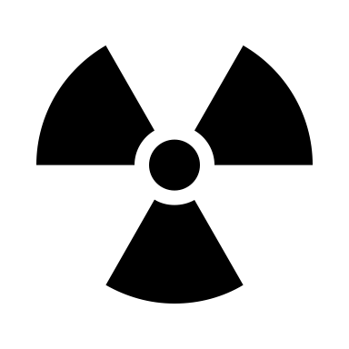 Information on the storage, transfer & use of sources of ionizing radiation at FSU
Health risks associated with exposure to ionizing radiation & radioactive material
Precautions & procedures used to minimize radiation exposures
Purposes & functions of protective devices utilized for radiation safety
Applicable provisions of Florida radiation control regulations & the FSU radioactive materials license and registrations
Workers’ responsibility to observe, to the extent within their control, applicable provisions of Florida radiation control regulations & the FSU license/registrations
Workers’ responsibility to report unsafe conditions that may constitute, lead to, or cause a violation of Florida rules
Appropriate responses to warnings made in the event of incidents having the potential to involve radiation exposure
Occupational radiation dose reporting requirements per section 64E-5.903, FAC
64E-5.1307(1), FAC Training Topics
Radiation safety principles, fundamentals and best practices
related to use of radioactive materials, including ALARA principles
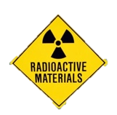
Radioactivity measurements
Radiation detection instruments and monitoring techniques
Biological effects of radiation
Transportation of radioactive materials
FSU radiation safety procedures
Practical experience with the use of radioactive materials
NAME:
 | Name |  |  |  | Signature
INSTRUCTOR(s):
 |  | Name |  |  | Signature
DATE: |  |  | LOCATION:

