RADIOACTIVE MATERIALS LAB SURVEY REPORT

Survey Date: |  |  | Surveyed By:
Survey Meter Mfr. & Model: |  |  |  |  |  | SN: |  |  | Cal. Date:
Survey Meter Checks: |  | Battery |  | Visual | Radiation Response (with check source)

Survey & Reporting Procedure
- Refer to the EHS Radiation Safety Manual for instructions on survey techniques
- Attach a diagram of the lab layout; list survey locations (name, #) on the diagram & this form
- Possible locations: floor, bench, desk, sink, door/drawer handles, centrifuge, incubator, refrigerator, freezer
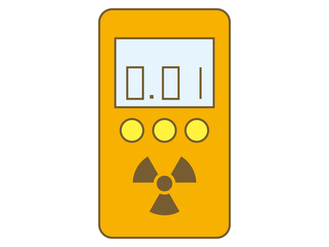
- Indicate survey technique by code:
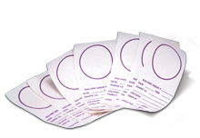

S Smear/swipe/swab results (cpm/smear)
GM G-M survey meter results (cpm/25 in)
NaI NaI survey meter results (cpm/25 in)
- Report all survey results in gross counts per minute (CPM); include background (cpm) for each survey set
- Indicate condition of survey results relative to background cpm [ex: BKGD, <2x, >3x, >10x, or >20x]
- Sign or initial and note clean-up or decontamination effort employed

 | Survey Technique  (S, GM, NaI) | Survey Location: Bldg./Lab) | Survey Results  (gross CPM) | Notes
1
2
3
4
5
6
7
8
9
10
11
12
13
14
15
16
17
18
19
20

Notes:

