RADIOACTIVE MATERIALS AUTHORIZED USER RECORD
State radiation control regulations [64E-5.208(1), 64E-5.1307, FAC] require the below information for all individuals seeking designation as an Authorized User (AU) of radioactive materials at FSU.
Principal Investigator: |  |  |  | RAM Permit No.:
Radiation Safety Training |  |  | Required Training Topics
Formal Training  & Duration: |  |  | Principles and practices of radiation protection, including ALARA principles  Radioactive measurements, monitoring techniques and instruments  Radiation units and terminology  Biological effects of ionizing radiation exposure  Radioactive materials transportation  Practical experience with use of rad. materials  Operating and emergency procedures
Practical Training
& Duration:
Experience with Radioactive Materials
RAM | Sealed (S) or  Unsealed (U) | Max.  Activity | Location of Use | Duration | Type of Use
I hereby certify that the above training information is correct.

Signature: |  | Date:
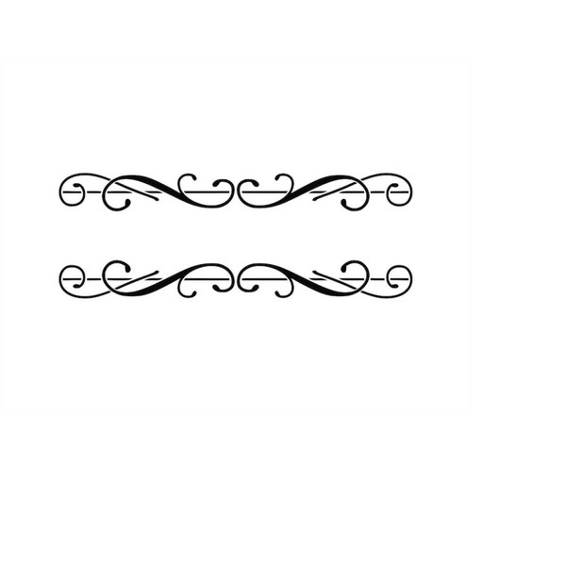

Notes:

