RADWASTE PICK-UP REQUEST
Person Requesting Pick-up
Name: |  |  |  |  | Email:
Campus Phone: |  |  |  |  | PI/Supervisor:

Location:
Building & Room

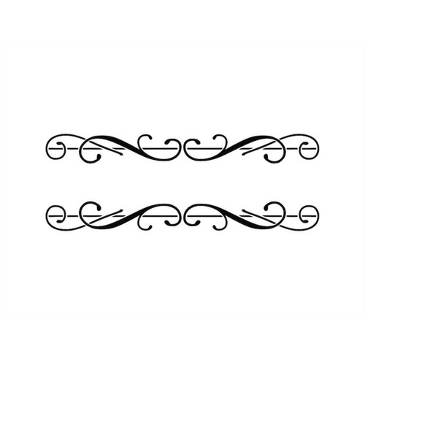
Description
Radioisotope |  | Form |  | Activity (mCi) |  | No. of Containers |  | Replacement Container Needed?

COMMENTS

NOTES:

